Project 4
Tracy Collamore
Post University

Sub-Topic #4
For the final learning activity, students will use 3D printing to discover, create, and analyze the architectural designs of major architectural sites from the Byzantine, Medieval, and Renaissance time periods. During these times, advances in architecture was a booming field where large, magnificent structures were being designed and built with great success. Using the online platform Tinkercad, students can discover several downloadable designs for historical buildings. They can use the platform to re-configure the found designs, and they can print each design into a series of smaller parts which will be assembled later. They will prepare an in-class presentation and conclude with a research/reflective paper. By using this hand-on experience, students will gain first-hand knowledge on how these structures were built, what holds them together, and why certain elements were designed by the architects.
Objectives
Using Bloom’s Taxonomy, students will expect to achieve a variety of measured objectives. Through the creation of a 3D design on Tinkercad, students will appraise the online creations and predict how each will clarify architectural elements, thus illustrating the evaluation level of assessment. Students will assemble their print outs to create a template of their chosen structure, where they will synthesize their knowledge through constructing, revising, and developing a completed 3D structure. Students will analyze their findings by identifying key components of architectural design, differentiate designs with other students’ projects, and examine their discoveries. Once completed, students will give a class presentation, demonstrating their comprehension of the material by distinguishing key facts to the group. And finally, students will illustrate their knowledge by writing a research and reflection paper, where first they will describe important facts of their chosen structure, and then identify how the process helped to explain the material in full.
Instructions
- Create a free online account on Tinkercad.com
- Complete the four tutorials that will be found on the main page of your account. Take a screen shot of your completed tutorials and email to the instructor.
- Practice creating your own design using this platform. It does not have to be complicated: you should be able to illustrate your understanding of the technology and provide evidence with a unique design.
- Using their online gallery, select a downloadable design of an architectural site from one of the following three time periods: Byzantine, Medieval, or Renaissance. Have this design ready for printing at school.
- Arrange a time to have your design printed on the 3D printer. You may need to return several times in order to print all of the pieces.
- Once the design components are printed, carefully assemble your structure. Pay close attention to how the building is assembled, and ask yourself the following:
  - How do these components work together to hold up the building?
  - Where are there unusual design elements used?
  - Why were these choices made by the architect?
- Prepare an in-class presentation explaining your process with this assignment and your knowledge on the key aspects and history of your chosen structure. Be prepared to answer questions and to ask questions to your classmates as they present themselves.
- Write a final research/reflection paper. Start with sharing key concepts of the time period, the structure, and the advancement of architecture it illustrates. Then, reflect on your experiences with this assignment: positives, negatives, and if you think this process provided a clear evaluation of the architecture of these time periods.

Activity
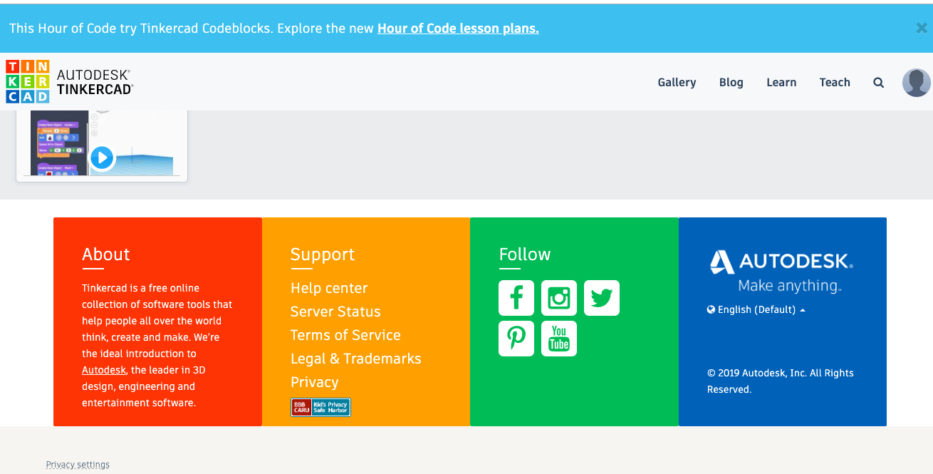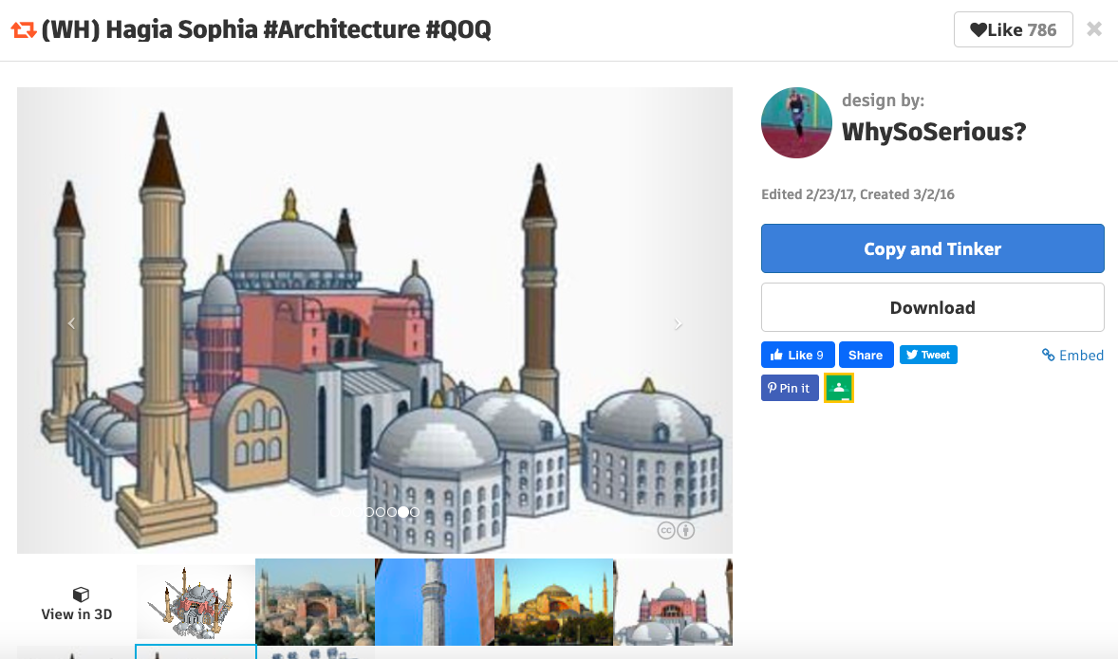

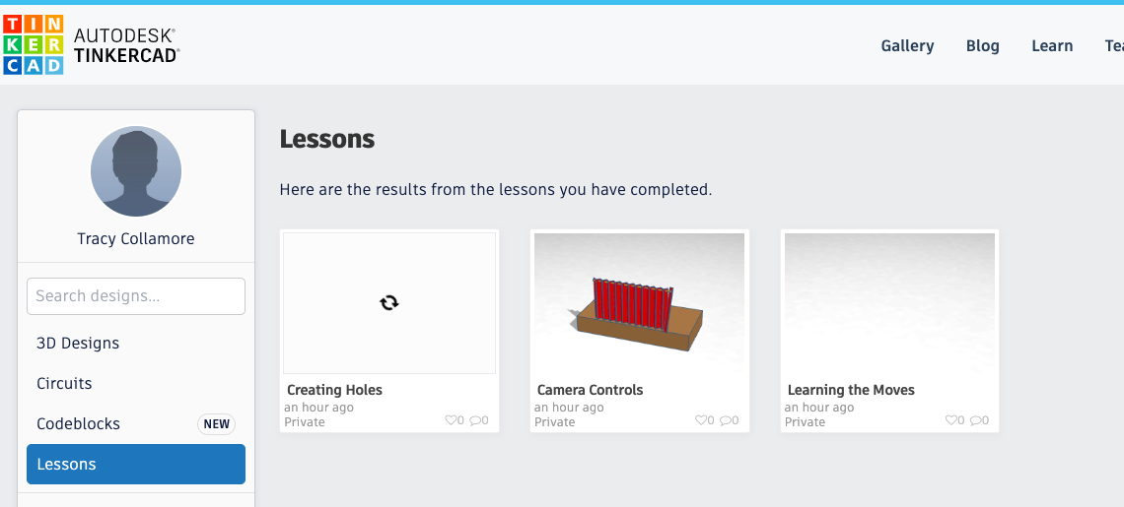

References

University of Maryland (n.d.). Bloom’s taxonomy: an introduction. University Libraries, College Park, MD. Retrieved from: https://lib.guides.umd.edu/c.php?g=598357&p=4142337

