Online Identity Proposal
Tracy Collamore
Post University

Outline Identity Proposal
As an education professional, having a positive online identity is imperative in the 21-st century workforce. As Martin Zwilling (2015) describes, establishing an online presence that accurately depicts your mission includes an active participation in the sharing of knowledge and information about oneself online. As an exercise in learning how to establish an accurate online presence, two education experts will be analyzed with the effort of cataloging their professional, digital profile.
Individuals and Qualifications
The two individuals who will be analyzed are Connie Malamed and Catherine Kehoe. Connie Malamed is an eLearning Instructional Design professional who focuses on creating learning models for the 21-st century learner and workforce. Malamed has degrees in Instructional Design and Art Education which gives her a unique perspective on the visual tools needed for optimal learning. She has received the Guild Master award in recognition of her achievements in the education industry (http://conniemalamed.com/). Malamed has an active and professional online presence using several digital platforms. She has a personal website with links to speaking engagements, consulting, books, and a newsletter. She is most active on the eLearning Coach website which she designed to share strategies, resources, and reviews for education professionals. Other sites where she is active includes LinkedIn and Twitter, and she writes articles for online education publications.
Catherine Kehoe is an artist and art educator. She teaches classes at the Massachusetts College of Art and leads workshops in her Black Pond Studio and at host spaces across the globe. Kehoe has an active online presence and shares resources for artists and art educators. She has a personal website with portfolios of her artwork as well as artwork from her students, and various essays written by peers on the subject of art and art education. Links in her website include various studio schools and galleries where she has worked and exhibited as well as information for her upcoming workshops. Kehoe established a website called “Painting: Powers of Observation” which is an ongoing collection of resources for artists and art educators. She curates this website and has many contributors to include interviews, artist reviews, catalogs of work, and articles that benefit art educators (https://catherinekehoe.com/). Kehoe uses Twitter and Facebook to share her online activity with followers.
Data Collection
In order to analyze the digital profiles of Connie Malamed and Catherine Kehoe, a catalog of online activity will be documented using the various online platforms both women use. Links to collaborative work will be cataloged along with professional and personal posts, to discover if their online identities create a professional appearance. Following Martin Zwilling’s (2015) outline of maintaining a positive online presence, data will be collected following the six criteria:
- Has their online identity been claimed? (Are there other Malamed or Kehoe profiles?)
- Do they actively contribute on their sites?
- Are they blogging with regularity?
- Are there any negative online content against their character or professionalism?
- Are there efforts for said content to be addressed?
- Does their online presence represent them with a positive, professional reputation?
Date of Post | Platform | Image | Summary | Positive/Professional | Contributors

Creating a table to catalog each online post, and then documenting each post against the six steps above (where applicable) will ensure accurate and appropriate data collection on Malamed and Kehoe’s online participation and professionalism.
Data Collected
The following tables reveal the data collected by following the online activity of Malamed and Kehoe:
Connie Malamed
Date of Post | Platform | Image | Summary | Positive/  Professional | Contributors
June 21, 2018 | Facebook | 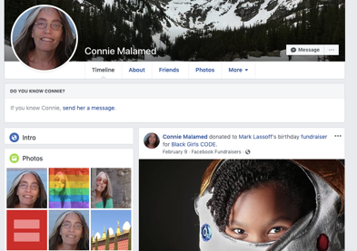 | Personal use: 321 friends, activity includes donations, political and LBGTQ equality | Yes/no | None (posts very little)
May 10, 2019 | Twitter | 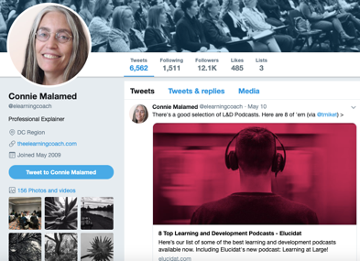 | A collection of top learning and development podcasts. Promoting peers in the field: daily posts | Yes/yes | Elucidat.com
May 2019 | LinkedIn | 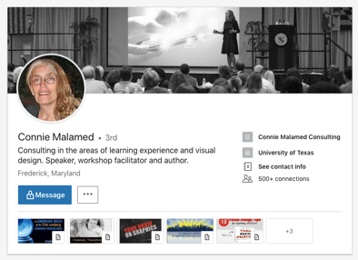 | 4000+ followers, actively comments on collaborators’ posts, shares links to podcasts. Endorsed by peers, lists all prof. qualifications. | Yes/yes | Julie Dirksen & Tracy Parish
May 2019 | www.conniemalamed.com | 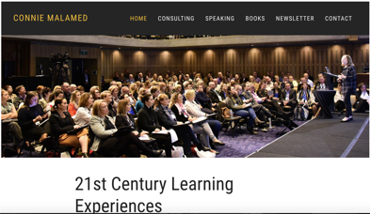 | Website promoting consulting, speaking, authored books, with newsletter and contact info. | Yes/yes | none
April 2019 | Podcast: the eLearning Coach | 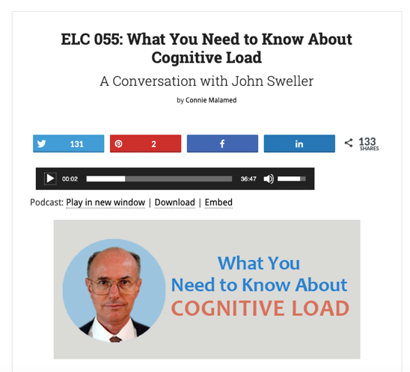 | A conversation with a professor/ educational psychologist on the importance of understanding cognitive load (how students learn). | Yes/yes | John Sweller, Emeritus Professor University of South Wales Sydney

Catherine Kehoe
Date of Post | Platform | Image | Summary | Positive/ Professional | Contributors
May 11, 2019 | Facebook | 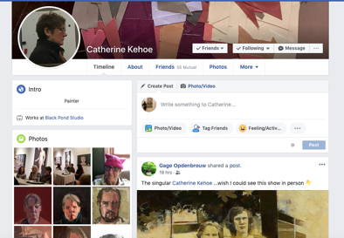 | Sharing a gallery exhibition where she’s participating, with link to location | Yes/yes | Westbeth Gallery
May 2019 | www.catherin  ekehoe.com |  | Online portfolio updated regularly with new paintings, available workshops, exhibitions, links to workshop locations | Yes/yes | none
2014 | www.powers  ofobservation  .com | 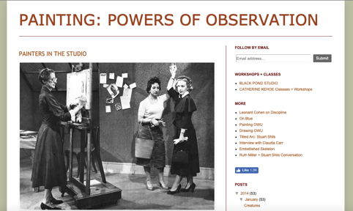 | Online tool for artists and educators: articles, blog, interviews, etc. Not been maintained. | Yes/maybe | none
May 2019 | www.blackpo  ndstudio.com | 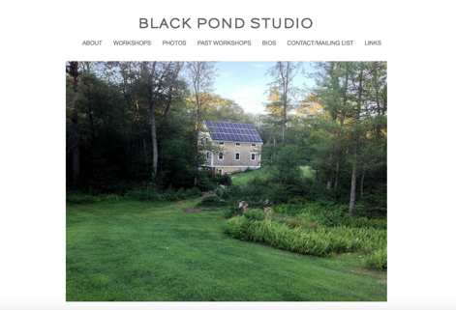 | Website to promote her studio workshops. Lists of available workshops, professional instructors, link to enroll | Yes/yes | Nancy McCarthy
May 11, 2019 | Instagram |  | Promotes exhibitions. Workshops. Many pics of her cats. 6000+ followers | Yes/sometimes | none
May 2019 | LinkedIn | 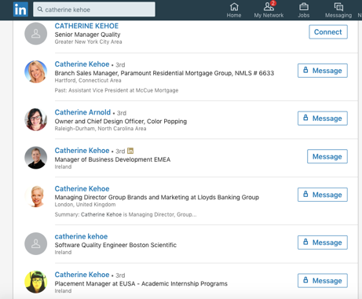 | No account. Seven other Catherine Kehoe. | No/no | none

Data Analysis: Connie Malamed
Connie Malamed has a strong, professional, digital identity, using several platforms to promote her work as an expert in educational design and reform. There were, however, a few instances where a lack of presence and professionalism appeared in certain social platforms. The first example of this is Malamed’s Facebook account. It is not known if she uses Facebook more frequently with private posts, but the public posts were donations to friend’s birthday parties and politically charged articles on the separation of families at the U.S./Mexico border. Her images included several with LGBTQ filters. She only has about 300 “friends”, so it can be assumed that Malamed uses Facebook for personal reasons. Although the content discovered here wasn’t exactly negative, it wasn’t professional either. This online content represents Colleen as a human being with opinions, political views, and personal passions. Unprofessional simply due to the lack of information related to her profession, which was prevalent elsewhere.
Malamed has several online sites and social accounts that clearly present her as a professional in her field. Martin Zwilling (2015) states that the first step of creating a positive online reputation is to claim one’s online identity before someone else does. Connie Malamed has clearly done that: a Google search displays pages of appropriate, professional content. She has two websites: www.conniemalamed.com and www.theelearningcoach.com. The first is a personal website designed to promote her work and her public speaking events. The following is an image of the home page:
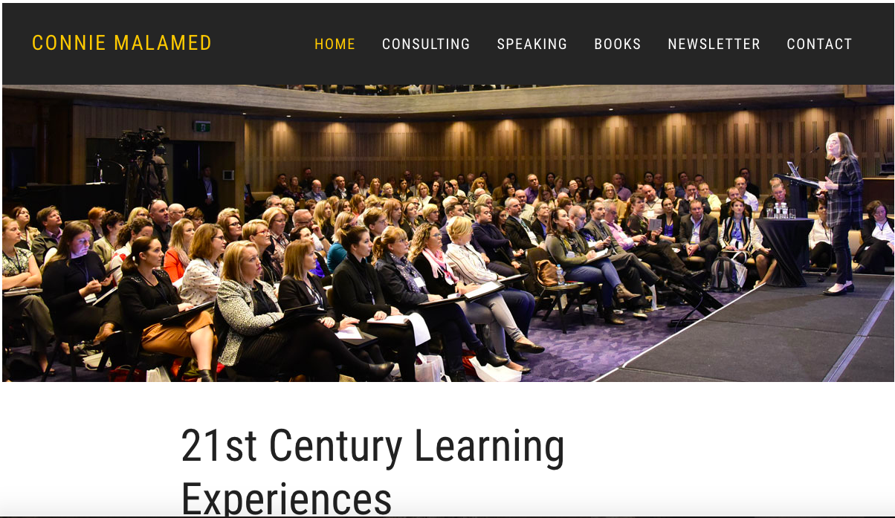
Pictured is Malamed in a public speaking event, which is one of her top advertised specialties. The image is clear and professional and provides a relevant visual to her credentials. Navigating the site is easy thanks to the user-friendly design. The header clearly relates all aspects of Malamed’s work. She has written two books which can be downloaded directly from this website. She also has a newsletter feature: however, one must provide an email account to receive her posts privately. A blog may would be a better online tool to enhance her online professionalism and active partipcation.
The second website is called the eLearning Coach – For Designing Smarter Learning Experiences. In this site, Malamed collaborates with other professionals in her field to share interesting and relevant information on designing new learning experiences. The following is an image of the homepage:
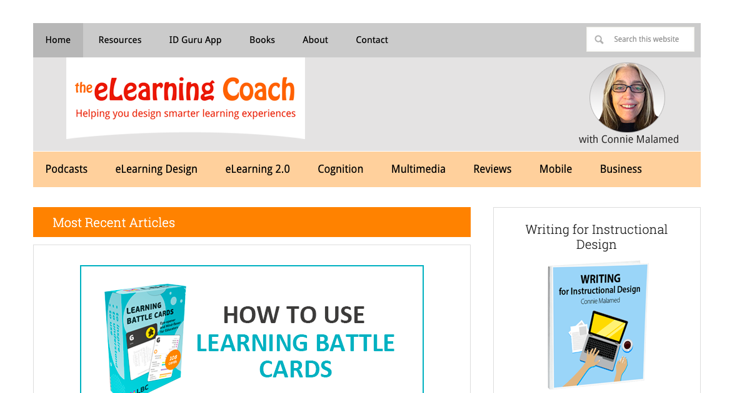
This website is not nearly as easy to navigate as her personal website: there are many categories in two headers which makes it difficult to find the desired information. There is simply a great deal of content on this site. With each page , there is a considerable amount of scrolling to reach the bottom of each page. The content itself, however, is professional. The Podcasts section is the most interesting feature of the website: Malamed interviews other professionals in the education field and each one is focused on a single topic. The website also features the ability of users to leave comments on the content, which all appear to be courteous and positive.
Malamed also has a LinkedIn and Twitter account. Unlike Facebook, Malamed uses these social platforms to strengthen her professional online persona. The following is an example of Malamed’s Twitter use:
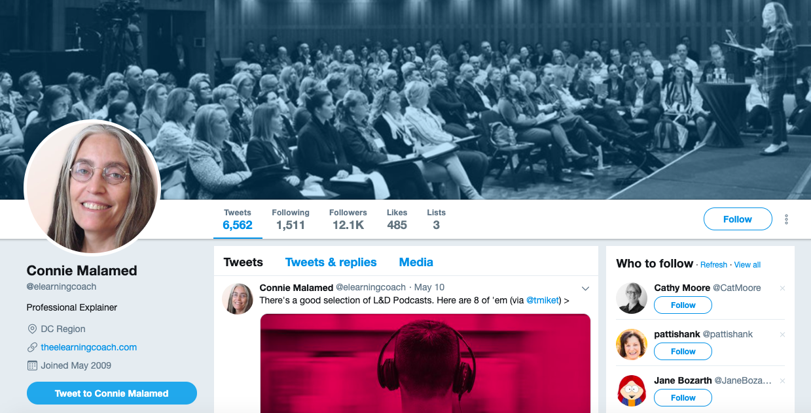
Malamed is incredibly active on Twitter, using the platform as a tool to promote her services and expertise, as well as support her peers in the field. She has over 12,000 followers and tweets professional content daily, sometimes twice daily. Her images are professional, and again, illustrate her work in public speaking. She describes herself as a “Professional Explainer”, a simple and light-hearted interpretation of her work. Within her posts and her profile, she shares professional content in an intelligent way, but it is also easy to read and welcoming. She is creating an online reputation here as being well-informed as well as approachable.
According to Zwilling (2015), blogging is a positive tool in creating a professional online presence and should be maintained frequently. The one major drawback concerning Connie Malamed’s online presence is that fact that she does not have a blog. The podcasts are the closest kind of posts to blogging, but do not provide dates on when they were recorded.
Data Analysis: Catherine Kehoe
Catherine Kehoe is as an artist and art educator that has a mix of professional and personal personas online. She maintains three websites that provide three services: her artist portfolio/resume, an on-going list of available workshops she teaches, and a resource page of articles and interviews for artists and art educators. The first, www.catherinekehoe.com, has a clear and concise design and provides all of her professional activity as an artist and educator as well as interviews with other professional artists. The information provided is professional and up-to-date with links to current exhibitions and workshops. The portfolio pages are updated frequently with new paintings, added as they are completed. Also included are images of her students’ artwork which illustrates her abilities as an educator. Second, www.blackpondstudio.com offers available workshops for artists located in her personally-owned studio building in Massachusetts. Featured are past, present, and future workshops, as well as links to instructor’s personal artist websites. Both websites provide the option to contact the artist through email with questions or comments. Neither site has a blog, or any other way to document daily activities to enhance her digital citizenship. The third website, www.powersofobservation.com, is intended to be a resource for artists and art educators. This site is loaded with relevant content, including articles, interviews, tutorials, links to archived information, and a blog. Pictured below is the homepage:

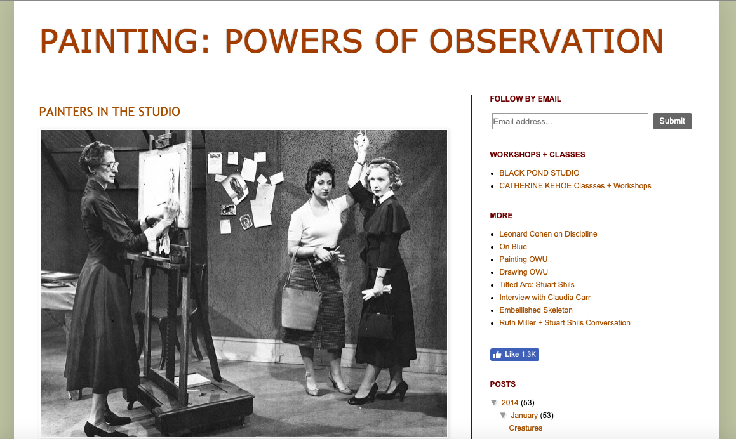
The blog on this website can be reached from the right-hand header, seen above. Unfortunately, it clearly indicates that the last activity on this blog dates back to 2014: there is no new content since the date indicated. This paints a slightly unprofessional online appearance, especially when considering Martin Zwilling’s (2015) concept of blogging often to appear relevant in today’s field. It is clear that, at one point, Kehoe believed in the benefits of blogging with her peers, however, the practice was ultimately dropped in her online routine.
Kehoe also has some social media accounts, including Facebook and Instagram, but is absent in others. Most of her posts on both platforms are professional in content, advertising her gallery exhibitions and workshop opportunities. There are also many posts that are pictures of her beloved cats. The following is the homepage of Kehoe’s Facebook account:
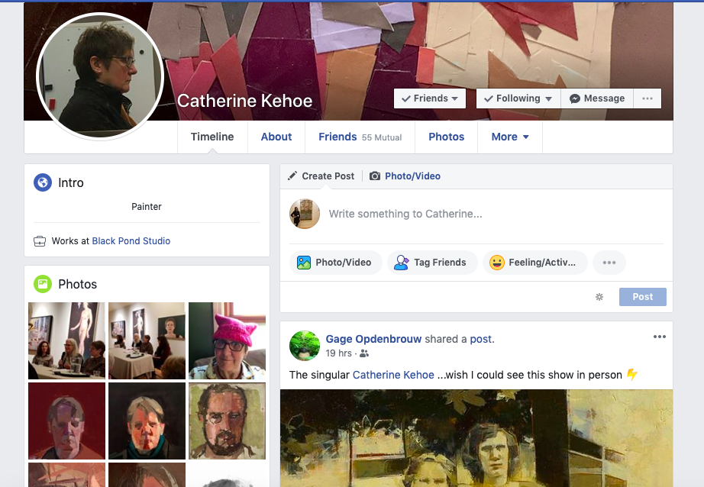The profile picture gives Kehoe the appearance of being a serious professional, and her cover image is a close-up of one of her collages which illustrates her profession as an artist. Many of her pictures and posts indicate a professional persona, but there are a few personal pictures and posts that do not. These posts are not negative, nor do they indicate any unethical online activity that could potentially cause her problems in the future: they simply illustrate her political views and personal life. Even though a professional online presence is beneficial, platforms such as Facebook and Instagram seem more focused on the ability to be more personable.
Where Kehoe is lacking with her online presence is her absence on LinkedIn. When conducting a search of Kehoe on that platform, seven other Catherine Kehoe’s appear. In this instance, Kehoe is not following Zwilling’s (2015) advice to claim all online formats before someone else does.
Impact on PLE Project
Throughout the process of researching Malamed and Kehoe, several strategies for maintaining a positive and professional online presence became clear, both in their strengths and their weaknesses. Malamed has a strong online presence as a professional in her field. Her websites are full of practical information and her credentials are clearly evident in several websites and social media platforms. With my PLE project, I will make clear my qualifications and experiences as Malamed has done. Links to other work, including collaborate projects, further strengthened Malamed’s online presence. I will look into ways in which I can present myself in my PLE project as being diverse in my experiences in this way. I can include links to past work that I have done to strengthen my profile and illustrate the diversity of my portfolio. My experiences in education has been in art, and I am currently teaching at the college level. I want to include content in my PLE project that will illustrate my passion of incorporating art education into a larger picture of education reform for a technology-rich future. With both Malamed and Kehoe, each website they maintain has several links to their other sites, which makes finding their information online more streamlined than a basic Google search. I will look to include relevant links to my other online accounts, including my personal artist’s website, and possibly my social media accounts.
In terms of “unprofessional” online presences, I can learn from both Malamed’s and Kehoe’s missteps. Although personal posts on platforms like Facebook is normal, I will filter what I share more so that I am not presented online negatively. Avoiding political posts is an easy way to maintain a positive online presence. I too share pictures of my dog on Instagram and Facebook, but I can also increase my sharing of professional material related to the arts and art education, especially if I intend to link my accounts on my PLE project.
Neither Malamed nor Kehoe actively participate in blogging on a regular basis: Malamed does not have a blog, and Kehoe’s has been neglected for years. The act of blogging regularly not only improves a professional online presence, it also provides an opportunity to connect with peers on personal reflections of learning materials. Unlike Malamed and Kehoe, I intend to continue blogging regularly in order to continue to develop my professional online presence.
Conclusion
In the 21st century, technology is quickly becoming the cornerstone of our society and workplaces. Learning how to use it properly in order to create and maintain a positive, professional, online presence is a critical exercise for many individuals seeking advancement in their education and careers. Observing the online practices of two professionals, Connie Malamed and Catherine Kehoe, provided an extensive knowledge in positive and negative practices that shape their online presence. We must practice the steps outlined by Zwilling (2015) in order to take control of our online persona and develop it into an image of who we want to be online.

References
About Catherine Kehoe (nd). Retrieved from: https://catherinekehoe.com/.
Connie Malamed Consulting (2019). Retrieved from: http://conniemalamed.com/.
Kehoe, C. (nd). Black Pond Studio. Retrieved from: https://www.blackpondstudio.com/
Kehoe, C. (nd). Catherine Kehoe. Retrieved from: https://catherinekehoe.com/
Kehoe, C. (nd). Catherine Kehoe Facebook account. Retrieved from: https://www.facebook.com/catherine.kehoe.33
Kehoe, C. (nd). Catherine Kehoe Instagram account. Retrieved from: https://www.instagram.com/catherine_kehoe/
Kehoe, C. (nd). Painting: Powers of Observation. Retrieved from: http://www.powersofobservation.com/
Malamed, C. (nd). Connie Malamed. Retrieved from: http://conniemalamed.com/
Malamed, C. (nd). Connie Malamed Facebook account. Retrieved from: https://www.facebook.com/connie.malamed
Malamed, C. (nd). Connie Malamed LinkedIn account. Retrieved from: https://www.linkedin.com/in/conniemalamed/
Malamed, C. (nd). Connie Malamed Twitter account. Retrieved from: https://twitter.com/elearningcoach
Malamed, C. (nd). The eLearning Coach. Retrieved from: http://theelearningcoach.com/
Zwilling, M. (2015). 6 keys to a positive online presence and reputation. Entrepreneur. Retrieved from: https://www.entrepreneur.com/article/249053.

